AIR MARINE INTERNATIONAL LOGISTICS (HK) LTD
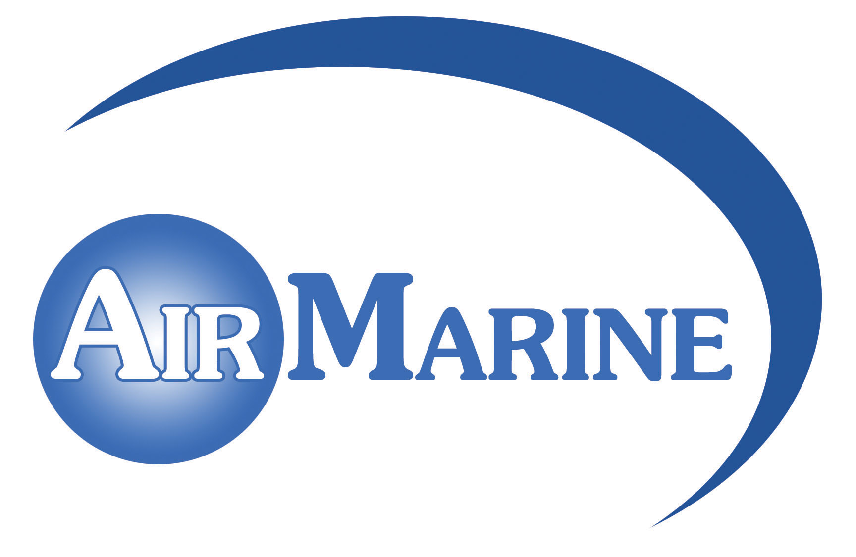
志宏國際物流有限公司

Flat A & D, 18/Fl., Nathan Commercial Bldg., 430-436 Nathan Road, Kowloon, Hong Kong.
Tel: 2384 6222 Fax: 2384 6821 E-mail: airmarine@air-marine.net Home page: www.air-marine.net

Known Consignor Aviation Security Declaration

1. On behalf of * (Name of Known Consignor) I, the undersigned, confirm that, unless otherwise stated, all consignments of goods consigned for carriage by air by *me/my company to Air Marine International Logistics (HK) Ltd.
:
- do not contain any explosive or incendiary device;
- are protected to my best endeavour against unauthorized interference during preparation, storage and transportation.
- are prepared by reliable staff employed by *me/my company.

- I agree that the packaging and contents of the consignments may be examined for security reasons.

Signature of Known Consignor | Company Chop
Name (Block Letters) | Company Chop
Position | Date
Company Address

Tel: Fax: E-Mail:
Company Business Registration Certificate No. (if applicable)

** delete as appropriate
** this declaration is renewable every 3 years

