AIR MARINE INTERNATIONAL LOGISTICS (HK) LTD
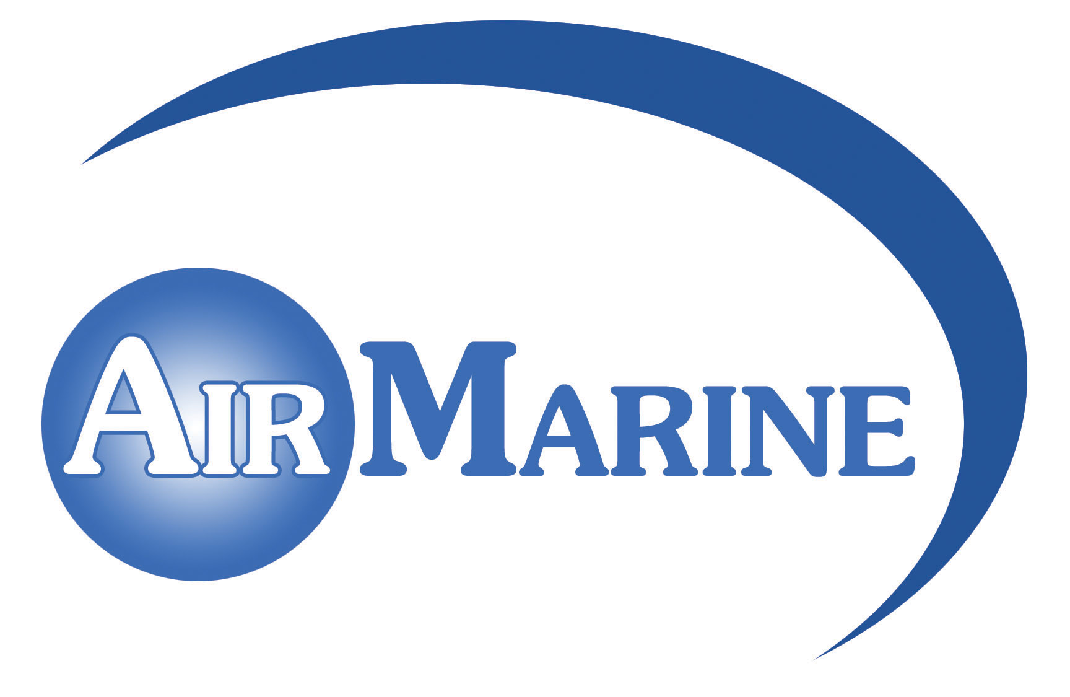
志宏國際物流有限公司
Flat A & D, 18/FL., Nathan Commercial Bldg., 430-436 Nathan Road, Kowloon, Hong Kong.
Tel: 2384 6222 Fax: 2384 6821 E-mail: airmarine@air-marine.net Home page: www.air-marine.net

物流服務表格Order Confirmation / Delivery Instruction

Exhibition name: 13th HK Mega Showcase & 13th Hong Kong Food Festival December 24~28, 2015
展覽名稱 : 13屆冬季購物節 & 13屆冬日美食節2015年12月24-28日

展館/攤位號Hall / Booth Number : ____________________/___________________
參展商名稱/聯絡人/電話號Exhibitor name / contact person / phone number :

_______________________________________________________________________

參展收貨日期Intended Pick up Date : _______________________

參展收貨地址Pick up address : ___________________________________________

撤館送貨日期Intended Return Date : _______________________

撤館送貨地址Return address :______________________________________________

件數Number of package : __________________________________________________

重量/尺碼Gross weight / measurement : ______________________________________

備註Special Instruction : __________________________________________________

_______________________________________________________________________

日期Place Order Date : _______________________
付款Payment term :貨到付款C.O.D. (accept company cheque or CASH on delivery接受公司支票或現金到付)
蓋章及簽署Agreed by exhibitor with company stamp & Signature :

_______________________________________________________________________

